EMERGENCY DEPARTMENT STROKE > 24 HOUR ORDERS

Physician to check appropriate boxes. These orders are not implemented until signed by physician.
☒ =Best practice. Physician must cross out pre-checked order if not desired.

☒ Document Time Last Known Normal: Date/Time:
☒ Document anticoagulant use & last dose:
☐ Tele-stroke Neurology Consultation: Date/Time:
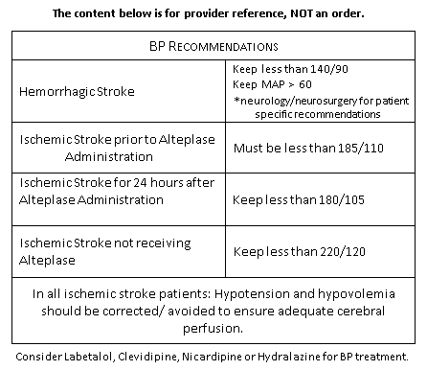
Diagnostics:
☒ Non-contrast CT head STAT
☐ CTA head STAT (if available)
☐ CTA neck STAT (if available)

Nursing Orders:
☒ Blood Glucose Point of Care STAT, notify for glucose < 60mg/dL or >180mg/dL
☒ Vital Signs & Neuro checks hourly
☒ Notify provider for BP > 220/120
☒ NIHSS
☒ Cardiac monitoring, continuous
☒ EKG
☒ O2 to keep SpO2 >94%
☒ Insert peripheral IV
☒ Nursing dysphagia screen prior to any oral intake
☒ Acetaminophen 650 mg PO/PR for temperature > 100.4 °F (38.0 °C)

Labs STAT:
☒ Troponin ☒ Lipid panel ☐ Alcohol Level
☒ CBC ☐ Urinalysis ☐ HCG Qualitative Serum
☒ CMP ☐ Drug Screen ☐ Hgb A1c
☒ PT/PTT/INR ☐ Other: ____________________________________

Verbal orders: (RN print) (RN sign)
Date/time: (Provider):

Provider: Date/time:
(sign)

