EMERGENCY DEPARTMENT CODE STROKE ORDERS
(Stroke arriving within 24 hours from last known normal)
Physician to check appropriate boxes. These orders are not implemented until signed by physician.
☒ =Best practice. Physician must cross out pre-checked order if not desired.

☒ Activate Code Stroke
☒ Document Time Last Known Normal: Date/Time:
☒ Document anticoagulant use & last dose:
☒ Tele-stroke Neurology Consultation: Date/Time:
☒ Consider Alteplase candidacy if within 4.5 hour window. (Consult with neurology. Refer to criteria)
☒ Consider Mechanical Thrombectomy if within 24 hour window. (Consult with neurology. Refer to criteria)

Note: In patients eligible for IV Alteplase, treatment should be initiated as quickly as possible. Blood glucose and brain imaging are required prior to administration.
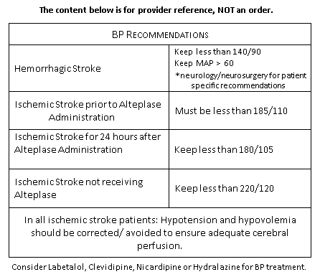
Diagnostics:
☒ Non-contrast CT head STAT
☐ CTA head STAT (if available)
☐ CTA neck STAT (if available)

Nursing Orders:
☒ Blood Glucose Point of Care STAT, notify for glucose < 60mg/dL or >180mg/dL
☒ Obtain weight
☒ Calculate Alteplase dose based on weight
☒ Vital Signs & Neuro checks q15 minutes
☒ Notify provider for BP > 185/110
☒ NIHSS (goal within 15 minutes of arrival)
☒ Cardiac monitoring, continuous
☒ EKG
☒ O2 to keep SpO2 >94%
☒ Insert large bore peripheral IV
☒ Insert second IV
☒ Nursing dysphagia screen prior to any oral intake
☒ Acetaminophen 650 mg PO/PR for temperature > 100.4 °F (38.0 °C)

Labs STAT: (should not delay IV Alteplase administration)
☒ Troponin ☒ Lipid panel ☐ HCG Qualitative Serum ☐ Alcohol Level
☒ CBC ☒ PT/PTT/INR ☐ Urinalysis ☐ Drug Screen ☒ CMP ☐ Hgb A1c ☐ Other: ___________________________________

Verbal orders: (RN print) (RN sign)
Date/time: (Provider):
Provider: Date/time:
(sign)

